Assignment: Git & GitHub Fundamentals

Part A: Theory Questions

1. What problem does Version Control solve in software development?
Version Control helps developers manage changes to source code over time. It prevents data loss, allows multiple developers to work on the same project simultaneously, tracks every modification, and makes it possible to restore previous versions if errors occur.

2. Define Version Control System (VCS).
A Version Control System (VCS) is a software tool that records changes made to files over time. It allows users to track revisions, collaborate with others, compare different versions, and revert to earlier versions when needed.

3. What is Git?
Git is a free, open-source Distributed Version Control System (DVCS) designed to track changes in source code during software development. It enables efficient collaboration, maintains complete project history, and supports branching and merging.

4. Explain the difference between Git and GitHub.
Git | GitHub
Git is a Version Control System used to track code changes. | GitHub is a cloud-based platform that hosts Git repositories.
Works locally on a computer. | Provides online storage and collaboration features.
Used for version management. | Used for repository hosting, collaboration, issue tracking, and code reviews.

5. What is a Repository?
A repository (repo) is a storage location for a project's files, folders, and complete version history. It contains the source code and all the commits made during development.

6. What is a Commit in Git?
A commit is a snapshot of the project at a specific point in time. Each commit records the changes made, along with the author's name, date, time, and a descriptive commit message.

7. What is the purpose of the Staging Area?
The Staging Area (also called the Index) is an intermediate area where selected changes are prepared before creating a commit. It allows developers to choose exactly which changes should be included in the next commit.

8. Explain the following Git architecture components:

a) Working Directory
The Working Directory is the folder where the project files are created and modified. Changes made here are not yet tracked until they are staged.

b) Staging Area
The Staging Area temporarily stores selected changes before they are committed. It acts as a preparation area for commits.

c) Local Repository
The Local Repository is stored on the developer's computer and contains the complete history of commits and branches.

d) Remote Repository
A Remote Repository is hosted on a server such as GitHub. It allows multiple developers to share, synchronize, and collaborate on the same project.

9. What is the purpose of the following commands?
a) git init
Initializes a new Git repository in the current project directory.
b) git status
Displays the current state of the repository, including modified, staged, and untracked files.
c) git add .
Adds all new and modified files in the current directory to the Staging Area.
d) git commit -m "message"
Creates a new commit with the staged changes and saves them to the local repository along with the provided message.
e) git push
Uploads local commits to the remote repository (such as GitHub).

10. Explain the industry workflow of Git from cloning a project to pushing changes.
The typical Git workflow is:
- Clone the remote repository using git clone.
- Create a new branch for the feature or bug fix.
- Make changes to the project files.
- Check the changes using git status.
- Stage the changes using git add.
- Commit the changes with a meaningful message using git commit.
- Pull the latest changes from the remote repository using git pull if needed.
- Resolve any merge conflicts if they occur.
- Push the committed changes to GitHub using git push.
- Create a Pull Request (PR) for review and merge into the main branch.

11. What information is stored inside a Git commit?
A Git commit stores:
- A snapshot of the project files
- Commit message
- Commit ID (SHA hash)
- Author's name and email
- Date and time of the commit
- Reference to the parent commit(s)

12. Why is Git considered a Distributed Version Control System?
Git is called a Distributed Version Control System because every developer has a complete copy of the repository, including its entire history. This allows developers to work offline and synchronize changes later with the remote repository.

13. What are the advantages of using GitHub?
Some advantages of GitHub are:
- Cloud-based repository hosting
- Easy team collaboration
- Backup of source code
- Pull Requests for code review
- Issue tracking and project management
- Branch management
- Integration with CI/CD tools
- Open-source project hosting

14. What is the difference between Push and Pull?
Push | Pull
Sends local commits to the remote repository. | Downloads the latest changes from the remote repository to the local repository.
Upload operation. | Download and merge operation.
Used after committing changes. | Used before starting work or before pushing changes.

15. Explain the role of Git in team collaboration.
Git enables multiple developers to work on the same project without overwriting each other's work. Developers can create separate branches, make independent changes, merge completed work, track contributions, resolve conflicts, review code through Pull Requests, and maintain a complete history of all project changes. This makes collaboration efficient, organized, and reliable.

Part B: Practical Assignment

Task 1: Git Configuration

1: Check Git Installation

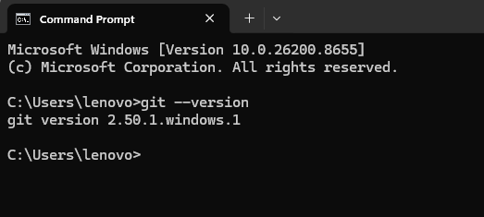

2: Configure Git Username

3: Configure Git Email

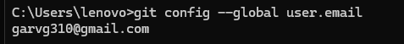

Task 2: Create a Local Repository

Create Project Folder

Move Inside Folder

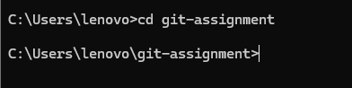

Create index.html

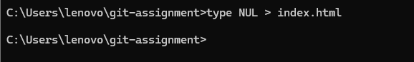Initialize Git

Check Repository Status
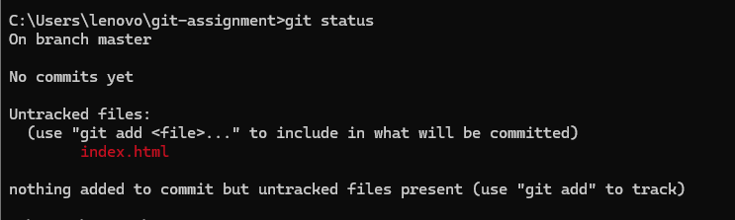

Task 3: First Commit
Open index.html and add:

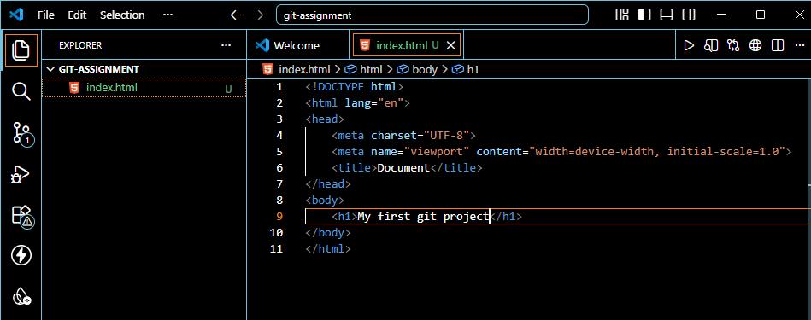Stage File
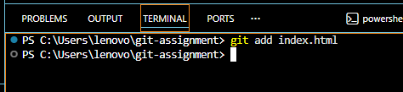

Commit

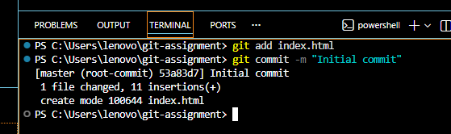

View Commit History
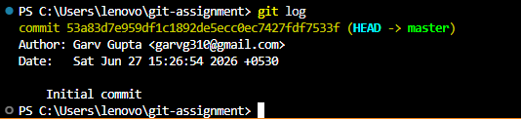

Task 4: Modify and Commit
Update index.html

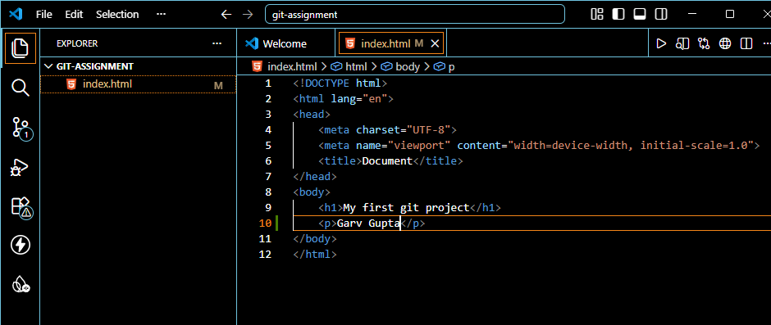Check Status

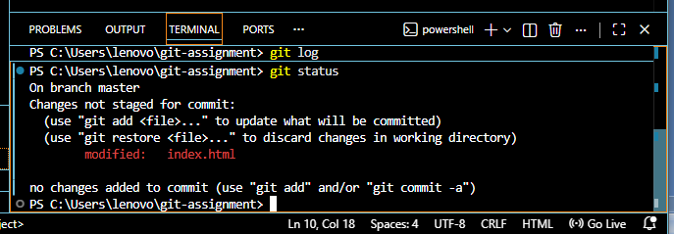Stage Changes

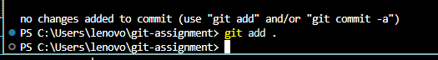

Second Commit

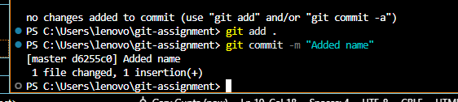

View History
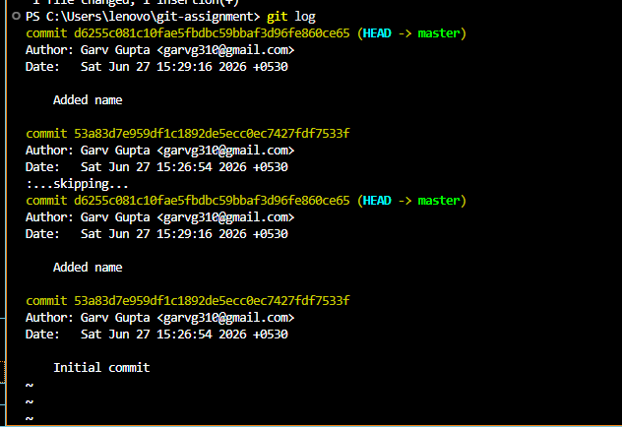

Task 5: Create a GitHub Repository
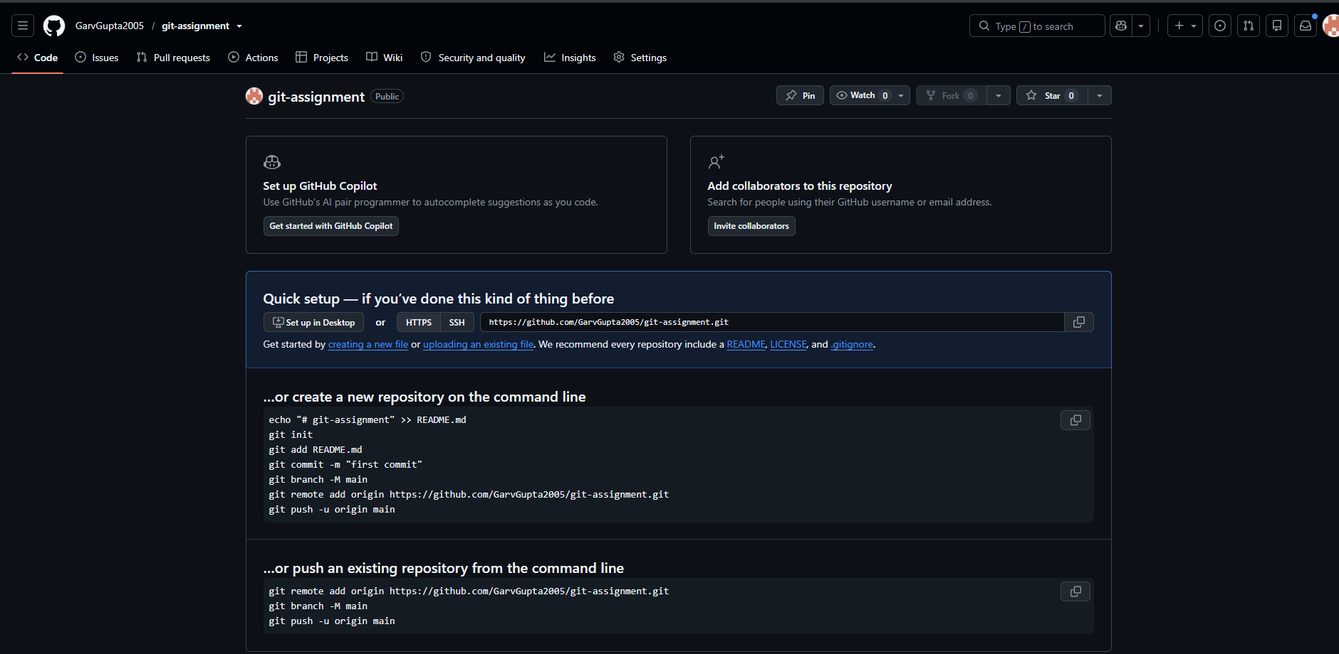

Task 6: Connect Local Repository to GitHub
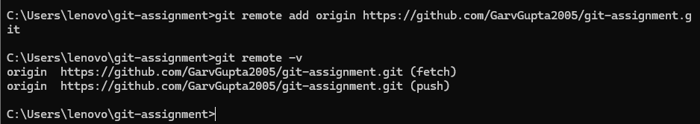

Task 7: Push Project to GitHub
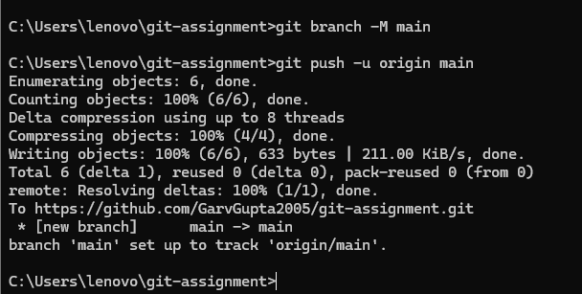

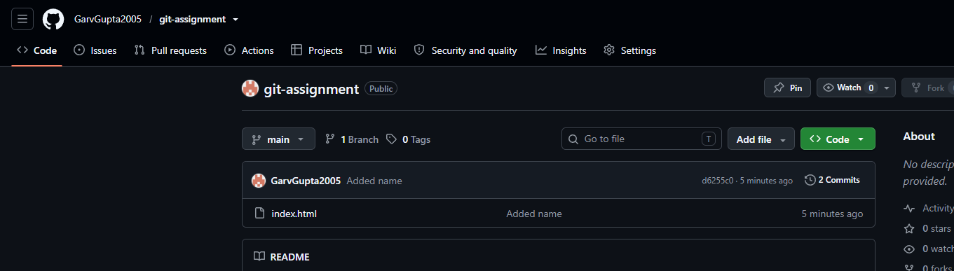

Task 8: VS Code Git Operations
